1. Margins determine the amount of space between the content of a worksheet and the edges of the printed page.

Top Margin: The distance between the top edge of the paper and the header or content of the worksheet.

Bottom Margin: The distance between the bottom edge of the paper and the footer or content of the worksheet.

Left Margin: The distance between the left edge of the paper and the content of the worksheet.

Right Margin: The distance between the right edge of the paper and the content of the worksheet.

Header Margin: The distance between the top edge of the paper and the header section of the worksheet.

Footer Margin: The distance between the bottom edge of the paper and the footer section of the worksheet.

1. 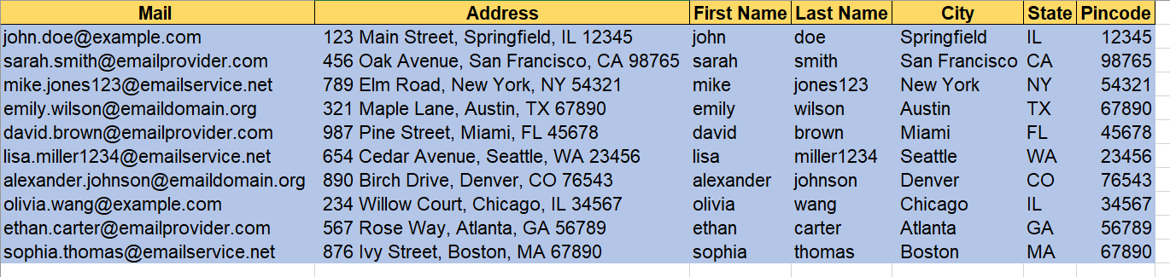
2. Freeze Panes is a feature in Microsoft Excel that allows you to "freeze" rows or columns in place while scrolling through a worksheet. This feature is especially useful when you're working with large datasets, and you want to keep certain headers or labels visible as you navigate through the data.
3. Margins determine the amount of space between the content of a worksheet and the edges of the printed page.

Freeze Panes: This option allows you to freeze both rows and columns simultaneously. It's useful when you want to keep specific rows and columns visible as you scroll.

Freeze Top Row: Selecting this option freezes the top row of your worksheet, keeping it visible even as you scroll down.

Freeze First Column: This option freezes the first column of your worksheet, keeping it visible as you scroll horizontally.

Freeze Panes (Custom): This option provides more flexibility by letting you specify the exact row and column where you want to split the worksheet. It allows you to freeze both rows and columns separately.

1. The different sheet options which are present are rename, move or copy, insert, delete, tab color.